Posted 08/11/2011 at 1:01 pm by JAV

Municipal Building Committee

Agenda
Town Hall, Conference Room
Wednesday, August 17, 2011

1 PM

- Approve minutes

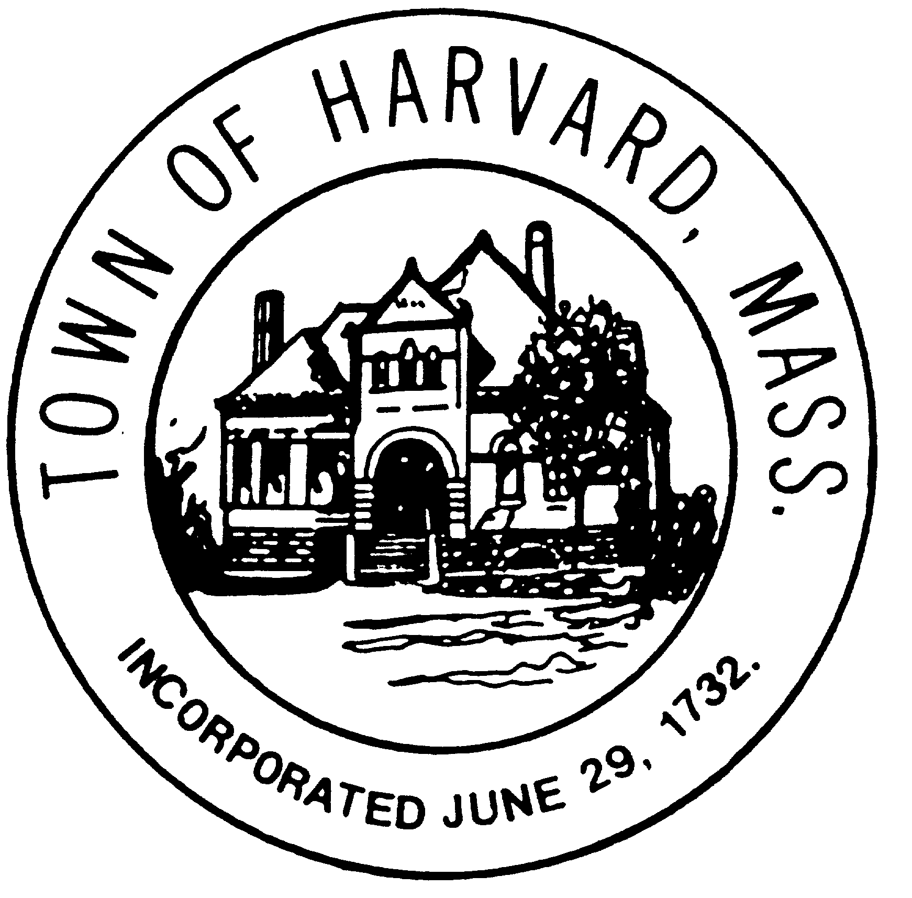
- Interviews with OPM Candidates
  - 2:00 - Design Technique Inc.
  - 2:30 - NETCO
  - 3:00 - SKANSKA
  - 3:30 - VERTEX

- Discuss OPM selection

- Agenda for next meeting

